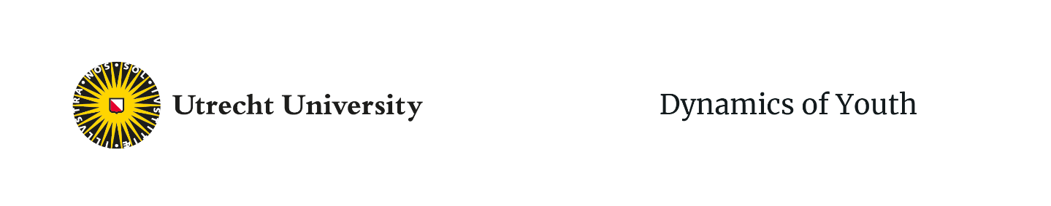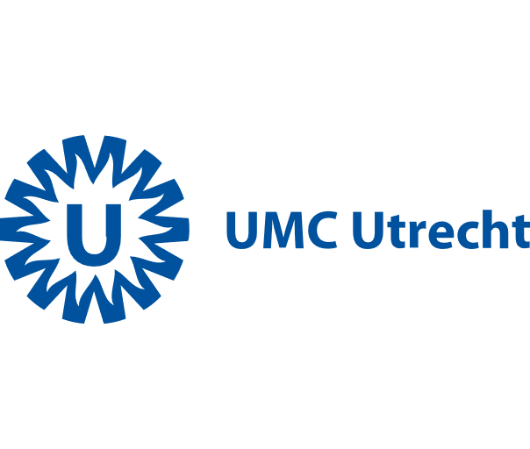

Child Health

**Application Form – Thriving & Healthy Youth – DiverseMinds Booster grant 2025**

Please submit your application for a Booster grant by filling out this application form.

**Deadline: April 30th 2025, 17.00h**

|  |
| --- |
| **Project title** |
|  |
| **Applicant information** *(at least 2 applicants from 2 departments, with at least 1 PhD student)* |
| (Copy for each applicant)  Name, title: Organization: E-mail address:  Name, title: Organization: E-mail address: |
| **Very brief project description** *(first ideas aim(s) and activities)* |
|  |
| **Hereby we certify that:** |
| If awarded the grant, we will spend the money responsibly within an interdisciplinary project team, adhering to the criteria as specified in the *Criteria* *DiverseMinds Grant* document.  The start date of the project is no later than August 2025 and the end date of the project is no later than July 2026. (Total duration of the project is no more than one year).  If awarded the grant, we will submit a short report (2-3 A4) after one year presenting the results of this project (both successes and failures are welcome, in line with our desire to be an evaluating and learning organization). |

**Signatures:**

Copy for each applicant

**Name:**

**Date:**

**Signature:**

**Name:**

**Date:**

**Signature:**

**Name:**

**Date:**

**Signature:**